**GENERIC ELECTIVE – 4**

**(OPEN SOURCE SOFTWARE)**

**Teacher: - Prof. Suparna Bora, Dept. of Computer Science & Engg.**

**ASSIGNMENT – 7.2**

**TOPIC- PYTHON PROGRAMMING**

**Prepared by- Name: - RAJDEEP DAS**

**Roll No. - 202151027**

**Course: - B.Sc. (H) Biotechnology,**

**2nd Semester**

**PROGRAM ON USING A LIST/TUPLE**

**Question:- Use a list/tuple containing 10 values. Iterate through the values and calculate the sum of the previous value and the current value.**

**Answer:-**

**Input:-**

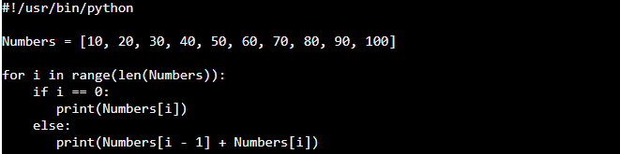

**Output**:-

